1)There are four very old cave paintings. Find the oldest paintingusing else if ladder. ŵ C++. 4200 years old, 8500 years old, 1000 years old 1300 years old.

#include <iostream>

int main() {

int age1 = 4200;

int age2 = 8500;

int age3 = 1000;

int age4 = 1300;

if (age1 < age2 && age1 < age3 && age1 < age4) {

std::cout << "The oldest painting is 4200 years old." << std::endl;

} else if (age2 < age1 && age2 < age3 && age2 < age4) {

std::cout << "The oldest painting is 8500 years old." << std::endl;

} else if (age3 < age1 && age3 < age2 && age3 < age4) {

std::cout << "The oldest painting is 1000 years old." << std::endl;

} else {

std::cout << "The oldest painting is 1300 years old." << std::endl;

}

return 0;

}

**Out put:**

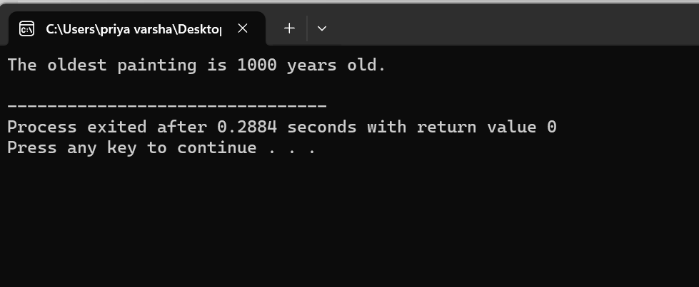

**2)** **One bus How many Carry. Can carry 48 children. children write parameterised a Can three buses C++ program using constructor.**

**#include <iostream>**

**class Bus {**

**private:**

**int capacity;**

**public:**

**Bus(int childCapacity) {**

**capacity = childCapacity;**

**}**

**void carryChildren(int numberOfChildren) {**

**if (numberOfChildren <= capacity) {**

**std::cout << "The bus is carrying " << numberOfChildren << " children." << std::endl;**

**} else {**

**std::cout << "The bus is overloaded. It can carry a maximum of " << capacity << " children." << std::endl;**

**}**

**}**

**};**

**int main() {**

**Bus bus1(48);**

**Bus bus2(48);**

**Bus bus3(48);**

**bus1.carryChildren(45);**

**bus2.carryChildren(55);**

**bus3.carryChildren(40);**

**return 0;**

**}**

**Output:**

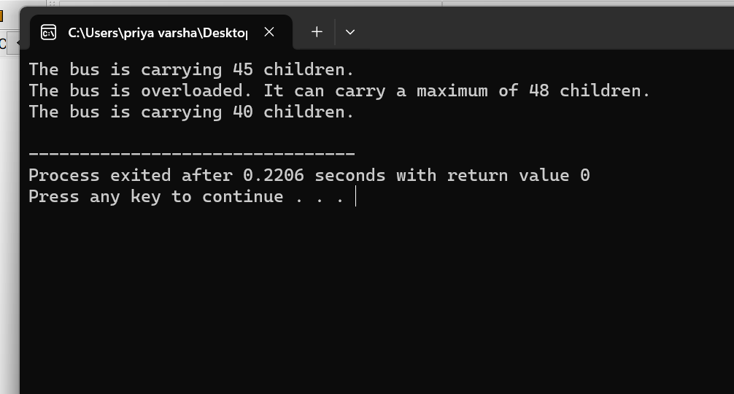

**3)** Kiran bought 1 kg plastic for $10, sold 1 kg plastic for $12. how much money does she earn on selling 1kg plastic?write a c++ program using default constructor.

**#include <iostream>**

**class PlasticTransaction {**

**private:**

**double costPrice;**

**double sellingPrice;**

**public:**

**PlasticTransaction() {**

**costPrice = 10.0;**

**sellingPrice = 12.0;**

**}**

**double calculateProfit() {**

**double profit = sellingPrice - costPrice;**

**return profit;**

**}**

**};**

**int main() {**

**PlasticTransaction transaction;**

**double profit = transaction.calculateProfit();**

**std::cout << "Kiran earned $" << profit << " by selling 1 kg of plastic." << std::endl;**

**return 0;**

**}**

**Output:**

